THE FUTURE OF THE LEFT

Bob Vinnicombe 16/12/2011

I think the left has very good future
- they've got control of the education curriculum
- most journalists are pro-Labor or pro-Green - Bob Brown only has to sneeze and it's news
- they've infiltrated all ranks of the public service
- they control academia
- they control the justice system and legal system - we've got judges who put people in gaol for 4 years for forming a political party, and let criminals out on the streets because "society's to blame". When Pauline Hanson and David Ettridge went to gaol, Richard Ackland, left wing journalist with a legal background, writing in the SMH said on 28/8/2003 "Most people I know think it is a singularly good idea that Pauline Hanson is in jail ....No one cares much what happens to her Svengali, David Ettridge."
http://www.smh.com.au/articles/2003/08/28/1062050604129.html
But the same journalist writing on 28/9/2008 however does care about what happened to the murderer Lewthwaite when he came up for parole, and though he scorned Bronwyn Bishop's statement that Pauline Hanson was a political prisoner said that Lewthwaite, because his parole was rejected because there was an election coming up WAS "what amounts to a political prisoner". Ackland also said "One psychologist I talked to said he was no more a risk to the community than any other murderer."
http://www.smh.com.au/news/opinion/playing-politics-with-a-mans-life/2006/09/28/1159337279816.html?page=fullpage
- public funding of elections has enabled people in power to use taxpayers' money to keep themselves in power
- registration of political parties which was brought in the 1970s have given the powers that be just one more mechanism to manipulate the electoral system to keep people out. A case in point is the experience of the British National Party . The BNP had in their constitution that non-white people couldn't join, I'm not exactly sure how they phrased it, but becasue of this their membership was put on hold, because that exclusion was declared illegal. Then they changed their constitution so that you could join the BNP as long as you agreed to their policies as set out in their constitution. Then they were told that was illegal too, because was one of their policies was to exclude non-white immigration which was discriminatory, so they were demanding people do something illegal as a condition for joining. Then they changed their constitution again so that to join the BNP you had to agree with every part of their constitution except the clause relating to restricting non-white immigration, and it was only then they could regain their right to operate as a party. This shows how it becomes impossible to make democratic changes to the laws of a country by getting elected on a platform to change those laws because it is illegal to want to change those laws.
- they've got their anti-vilification laws in place to slant peoples' minds to a certain way of thinking and supress criticism of their policies
- and as I will seek to show, the so-called conservative parties have adopted part of their agenda

It Started Partly With The Vietnam War

How did this happen? You can't overestimate the radicalizing effect of the Vietnam war. The youth of Australia and America had the prospect of being conscripted and sent to Vietnam and told to shoot some people called communists, and they said, well, if we're going to shoot people because they're communists, maybe we better have a look at what communism's all about. Maybe it's not so bad and it might be good for a country like South Vietnam. During the Vietnam war the forces of freedom lost the propagnada war from the start - as an academic at Sydney University wrote "The Battle of Trafalgar was said to have been won on the playing fields of Eton, the Vietnam war was lost on the campuses of American Universities". I was at Sydney University 1969 to 1971 at the height of the moratoriums, SDS, the Sydney University Labor Club and so forth, and I saw people from middle class conservative homes brought up on a Readers Digest view of communism suddenly waving Vietcong flags talking about American Imperialism and saying a victory by the North Vietnamese would be a good thing. Whitlam was partly brought to power by the Vietnam war. Despite the holocaust of 3 million Cambodians murdered by the maoist communist Khmer Rouge, the Vietnam experience gave many people a rosy picture of communism.

It's amazing how many of the activists of the late 60s and early 70s went on to be the political movers and shakers of today - Tony Abbott was President of the Sydney University SRC in the late 70s, a few years after Jim Spiegelman, who of course is a high court judge and was once I think Whitlam's personal secretary.The present president of the NCC successor to BA Santamaria was the main anti-communist student politician at Sydney University in the late 60s and early 70s, Peter Westmore.

It Also Started With The Counterculture of the 60s and 70s

The 60s and 70s were the age of the counterculture, psychadelic drugs, dropping out and we had a bizarre coalition between marxsim and hippiedom - we had people who really were really apolitical throwing round words like "bourgeois" and "fascist" and wanting to get rid of the existing order, but had no idea of what would replace it except it would be a world where you could have as a many drugs as you liked and you would never have to work It was about the time the Beatles got mixed up the the maharishi in India and went psychedelic. The John Lennon song "imagine there's no heaven, imagine all the people living as one ".. could be called the anthem of the multicultural, globalised new age that was coming . When Janis Joplin sang "Freedom's just another word for nothing left to lose" it was a put down for all the apologists for capitalism that summed up the entire works of Marx, Lenin, Mao and Kim Il Sung in one sentence. It suited the Left to exploit the counterculture because it was just one more thing that would bring down capitalism, though some on the Left differed. I remember a letter in the communist Tribune newspaper lambasting them for printing what the writer called the "trotskyist clap-trap of Dennis Freney" about taking drugs and dropping out because they thought in a socalist economy everyone shoud have to work.

Of course now Paul McCartney's a multi billionarie and so would John Lennon be if he was still alive - which reminds me of a cartoon in Mad Magazine once - a father's reprimanding his scruffbag son for listening to rock music, and he says "When I was your age, all my heroes were millionaires". The son says derisively "Urrhhh! millionaires,. you've probably never heard of our heroes - Bob Dylan, The Beatles, Simon & Garfunkel..." and the father says "Sure I've heard of them - they're all millionaires!".

Then Left and Right Discovered Economic Rationalism

But ten years after the demise of Whitlam significant things happened . The Chinese communists suddenly discovered that it was good to be rich, and the Left in the West embraced economic rationalsim, as when Hawke said that an economy needs a healthy private sector as well as a healthy private sector. This is why the flavour of the Hawke years was totally different from Whitlam years,Whitlam had nothing but contempt for private enterprise and though he wasn't a revolutionary socialist he thought that that capitalism was at best a neceesary evil, and the only people of real substance were people who worked in some arm of Government.

I can remember whan Hawke first became president of the ACTU, and there were strikes everywhere, and every time there was a strike he would support it, and he was asked by a reporter something like "Come on Mr Hawke, why are you supporting all these strikes and stuffing up the system just when we're producing all this wonderful mineral wealth" and his answer was "I'm aware of all the wealth that's being produced, what I 'm concerned about it, is how is that wrealth distributed?" Forty years later, we've found out how Hawke wanted the weatlh of Australia distribuited. A lot of it has been distributed into his own pocket, because he's a very wealthy man - same goes for Paul Keating and people like the late and not lamented Lionel Murphy etc. Any socialist who dies rich is a fake.

So now with the Chinese Communist Party finding its good to be rich, and all the Labor icons and the icons of the 60s & 70s counterculture becoming millionaires, we've come a long way from the 60s when Danny the Red, Daniel Cohn-Bendit, who I believe is now a big wheel in the European Greens, proposed that under what he called the Left Wing Alternative to Obsolete Communism everyone's wages should be the same, whether you were a teacher, a doctor, a factory worker, a membe rof parliament or a street sweeper. But I'd like the ALP to explain while an average Labor voter works two jobs and still can only just afford a two-bedroom fibro house in a suburb no-one's ever heard of 20 miles west of Liverpool, multi million dollar homes in the Eastern Suburbs are being bought up by rich corrupt officials of the CCP so they keep their ill-gotten gains out of the hands of the government in Beijing.

At the same time as the Left discovered that private enterprise could be good, the so-called conservative parties also discovered economic rationalism Now you might think that economic rationalism was just a new name for laissez faire capitalism, a fringe political ideal embraced by well-meaning but misguided people like Ayn Rand who advocated total de-regulation of business, no social services and no government interference in the economy whatsoever. But whereas Ayn Rand's ideal which she encapsulated in works like The Virtue of Selfishness and Capitalism the Unknown Ideal, were based on a fear of socialism having been a refugee from the Soviet Union, and a belief in the ultimate virtue of liberty of the individual, in my opinon they were really embracing dialectical materialism - an idea that the only thing that matters is material welfare - the greatest good for the greatest number - so forget God, Queen and country, liberty, tradition, heritage, patriotism, free speech, the family as the basic unit of society, whatever else the conservative parties used to claim to stand for, their policy became that if we close down all the factories and farms and import cheap goods form overseas, sell mining rights to the highest bidder .....it doesn't matter, as long as in the end everything in the shops is by this means ten per cent cheaper. If there's only two players in the retail game - it doesn't matter because they employ lots of people and pay them award wages, and they pay big returns to their shareholders. Or as Bill Clinton put it - "It's the economy stupid!".

Malcolm Turnbull, and more of him later, similarly says his policy is "Jobs, jobs, jobs" which sounds like something coming from a depression era communist than a Liberal.

The Demise of the Concept of the Individual

I remember seeing Andrew Peacock interviewed when he became leader of the Opposition and he said he had joined the Liberal Party because he wanted a party where the emphasis was on the individual, and that used to be the difference between the Liberals and the Labor Party and between the Democrats and the Republicans in the USA, the concept of the individual as against the collective. If you asked a Liberal these days what he thought of this concept, leave alone being for it or against it, he wouldn't know what you're talking about. These days the only freedom the Liberal Party believes in is the freedom to make money. But what I say is, democracy is all very well, but democracy might be just a dictatorship by the majority, besides democracy you've got to guarantee individual liberty. But the marxist says that the concept of the individual is an invalid, bourgeois concept because the ony thing that matters is the well-being of the masses. But there's a flaw in that, because the masses are individuals.

Denying the Chinese Holocaust

Let's consider a speech by Malcolm Turnbull, made to the London School of Economics recently , He gave his speech the peculiar title "Same Bed Different Dreams" talking about Communist China.

I say "Communist China", because there are two Chinas - there is Communist China, and there is the Republic of China, sometimes called Taiwan. People who come here from Taiwan come here on a Taiwanese passport which proves there are two Chinas. .

As revealed in the book recently published by Frank Dikötter Mao's Great Famine based on painstaking research in newly opened local archives 45 million chinese people died because of the great famine caused by the Mao's communism during the so-called "great leap forward". Let us also not forget the Chinese Communist regime propped up the murderous Khmer Rouge in Cambodia so must take part of the guilt for the 3 million who died there.

China is now a land where political prisoners are killed so their organs can be sold on the black market, and women suffer forced abortion and forced sterilization due to the one child policy. There are 100s of thousands of political prisoners in concentration camps forced to produce goods, including Christmas decorations, that our sold in our shops. It was publicized recently how a 2 year old was hit by a car and lay there for two days before anyone took it to hospital.The reason this happened says a lot about the China that communism has created. The first reason is no-one in China now cares about anybody else. The second reason is anyone who picked the kid up and took it to hospital would have a good chance of being charged with having run it over, because the authorities couldn't believe anyone would do any such thing with any motivation but a gulity conscience, and of coursde once your charged with anything in China, that means you're guilty.

But what does Malcolm Turnbull say about the last 60 years of Chinese history. He draws an evolutionary connection between the Mao suit, which in fact, was a device to destroy the concept of the individual, and the modern Chinese CCP operative strutting round the world doing deals in neatly tailored business suits.

He admits that China is not a democracy but calls the one party dictatorship a social contract. Sorry, Malcolm, a contract is a voluntary agreement between two parties - like you vote in the Gillard- Brown government for a three year contract, and kick it out at the end of that time if you don't like it which is simply not renewing the contract.

He says the Communist Party of China presents as a modern political party.The CCP isn't even really a political party, seeing it's a one-party state, or does Malcolm Turnbull think one-party rule is the modern way to run a country? But they have sent official delegations to Liberal Party conferences in Australia. Did you know the CCP gets to observe Libveral Party conferences? Do ordinary citizens get an invite? Does the Liberal Party get an invite to the meetings of the central committee of the CCP?

He describes the Japanese invasion of China as brutal, but makes no mention of the brutal Chinese communist invasion of Tibet or of the brutal way the communists seized power.

You see this is where I get confused, I thought that when the communist scame to power they kill the rich people like Malcolm Turnbull, the non-producttive bankers and lawyers who just live of the labor of the working class, and re-distrubuted their wealth to the peasants.

Then he says, quoting the dictator Mao, "The Chinese people have stood up"

What does Turnbull mean by China "standing up". The possession of weapons of mass destruction? Subjurgating the people of Tibet? Their sabre rattling about Taiwan, and that large chunk of the Eastern India which they lay claim to? Flooding the world with shoddy manufactured goods made with slave labour? Doing deals with African dictators to acquire oil and mineral rights and the right to grow food on their land? Does he mean cornering the market for rare earth elements? Even in purely economic terms China is a country where unlike South Korea and the Republic of China most people live in poverty, it's the most polluted county in the world and I defy anyone to name any invention, any quality manufactured product, or any cultural or artistic achievemnt, apaer from dissident literature, that has come out of China since 1949. Anything of value which has come out of China, or any other communist country since 1917 has been in spite of communism, not because of it.Oh, sorry, that's right, their AK47's are very reliable.

And Malcolm Turnbull certainly doesn't want Australia to "stand up". If he has his way, Australia will be nothing but an accounting concept on the annual balance sheet of Goldman-Sachs - a big hole in the ground where multimnational mining companies rip the minerals out of the earth and export them with the profits going to their investors. He doesn't want the country where his ancestors came from, Britain, to stand up I'm sure he's eager to see the UK disolved into being just another state of the EU, which of course is another socialt constuct, and he doesn't want another country that had an equally great and glorious histary as China, Iran to stand up. And he certainly doesn't want Tibet to stand up.

But it's not the first time that coalition politicians have grovelled to the Chinese Communists. On 14th September 1976 after Mao did the world a favour by dying, a condolence motion was moved in Federal Parliament MPs spoke to the motion.

One said: "He welded the difficult factions in China into a cohesive and united nation.His achievment was remarkable by any standard."

Another said: "Mao devoted his life to a vision of a rigourously egalitarian society and secured the basic nexessities of life for the chinese people ...he achieved peace internally."

Another said "He organised great land reform .... He was ...a humane head of a government...."

Did these words come from Dr Cairns or Lionel Murphy? No - that was Doug Anthony, Malcolm Fraser and Senator Reg Withers who a few years before had sent 500 Australians to die in Vietnam to fight communism, and "contain China" and whose founding father, Bob Menzies, had wanted to ban the Communist Party.

For the record he didn't organize great land reform and he didn't weld the difficult factions in China into a cohesive and united nation - he engineered a one party dictatorship in which the party hierarchy had all the power and the people nothing.

For the record, he didn't secure the basic necessities of life for the Chinese people, fact millions starved in in the ill-fated cultural revolution. and he didn't achieve peace internally, his killed millions of them.

And here is what the Labor MPs said: Whitlam: .."Under Mao's leadership, the chinese people found the strength for a prodigious effort of revolutioany struggle....he was the authentic father of his people and the new China".

Tom Uren said "Mao was a great leader, a brilliant revolutionary thinker....an outstanding patriot...by he people of China he was not only respected he was loved"

Mick Young said "The first government in history to ... to have the support of all the chinese people."

I suppose if you kill all the people who don't support you, and threaten to kill anyone else who doesn't support you, you'll have the support of everyone who's left.

For the record Billy Wentworth spoke against the condolence motion, and Kevin Cairns, Col Carige, and Labor's Dick Klugman walked out on it.

Condemning Mao's 'treachery and terror', Wentworth compared Mao to Hitler and Stalin, saying "many praised the dead Stalin before they realised the true nature of the monster. And most now praise Mao....Maoism has subjected the Chinese people to an alien ideology and has denied them all their traditional life and culture. It has demanded the rejection of all family ties and accepted decencies, culminating in its assault of Confucianism. For religion it has substituted the ritual nonsense of the Little Red Book, the analogue of the ridiculous 'Heil Hitler' of the Nazi discipline."

But it's not the first time the so-called Western democracies have grovelled to communist dictators - Anyone who's old enough will remember the "Men of Stamina" Crusader Cloth and Stamina Trousers ads that featured in Australian magazines right up to the sixties, depicting heoric men who all Australian boys should look up to . Here I have one from 1944, from Walkabout magazine, featuring Charles de Gaulle. Among others were Baden Powell, Winston Churchill, Franklin Roosevelt and people like that . And here is another one - Joseph Stalin. The blurb says:

"Stalin 'man of steel', the son of a cobbler, is probably the most powerful human being in the world today.His perseverance is inhuman, his physical strength and endurance are enormaous. He is a supreme organizer. He took over the Russian revolution and made it work. Neither gaol, nor exile, nor revolts nor the threat of assassination have daunted. Leading Russia to victory, he stands out pre-eminently as a man of Stamina."Another advertisement featured the Communist Dictator Tito, idolised as a "Man of Stamina". It says "this almost legendary, fearless, quiet man stands out as he stands for his country's freedom ......supremely a man of Stamina. "

If you go to Slovenia now you can see where they have opened the caves where the skeltoal remains of thousands of anti-communists killed by the Tito's communist soldeirs were thrown.

It was Stalin in 1944, it's Mao in 2011.

Apart from the criminalty of these words, what's scary is, if they admre what Mao did, is this what the powers that be now have in store for us? Land reform, of course, meant taking away everyone's land rights. Are they looking at the CCP model and thinking, well that's a pretty good way to run a country - strong central government, a compliant media and no-one being allowed to stand in the way of the almighty dollar. The way CSG is being pushed through by both major parties, when it's manifestly obvious it's an infringement of property rights and going to pollute the environment, is how the CCP runs China.

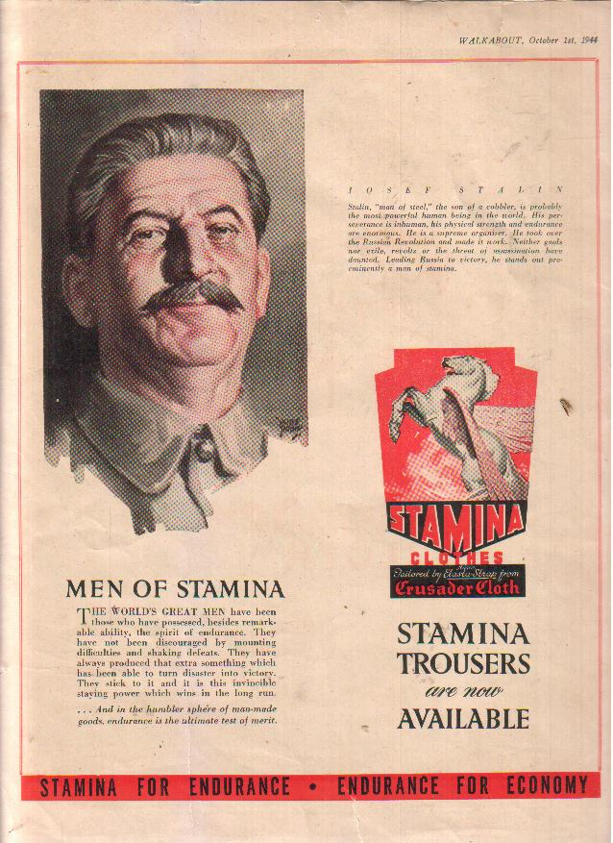

The indifference of the economic rationalists of today to the abominations of communism reminds me of that scene in the film "The Third Man", scripted by Graham Greene, which was made just after the war, where Orson Welles and Joseph Cotten are up in the ferris wheel and Orson Welles, as Harry Lime, who has been selling impure penicillin on the black market and causing great death and misery
thereby, says to Joseph Cotten, "Look at those people down there, they're just like ants. If I offered you a million pounds for everyone of those you could bump off, do you mean you wouldn't take it? Governments don't talk about 'people' any more, dear boy. They talk about 'the proletariat'. They talk about 'the masses'......"

If the Vietnamese communists hadn't overthrown the Khmer Rouge, and remember the Khmer Rouge were simply Maoists on steroids, the Khmer Rouge would have evolved into what Communist China is now and when Pol Pot died Liberal and Labor MPs would have been getting up in Paliament and saying what a great guy Pol Pot was and what great things Pol Pot had achieved for Cambodia.

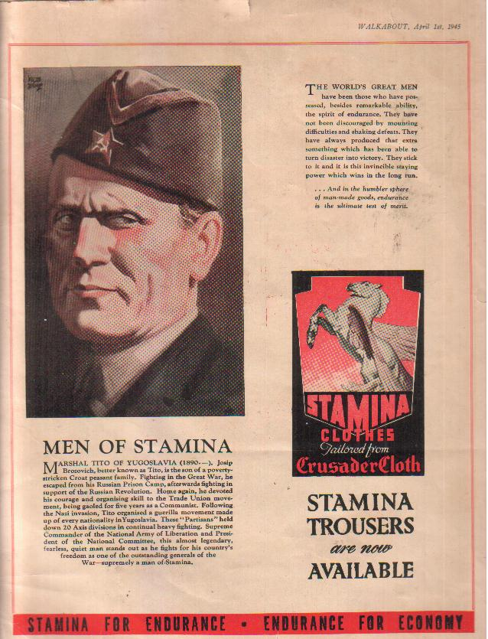
The vested interests who want to make money out of China don't want democracy in China. I used to work for a company that were the agents for all the textiles and garments that came out of China. After the Tiananmen Square massacre one of the executives was asked "It must be tough doing business
there now?" and he said "No, now it's easier doing business there now - because now everyone's doing what they're told!".

The ideal country for a capitalist to deal with is one where there is a strong and pragmatic central government who will asist you in doing business all over the country, rampant corruption, no free press to expose corruption, pollution or working conditions, slave labour and no trade unions as such to disrupt production - in other words - a communist country.

You see what these people we actually doing is denying the chinese holocaust. It should be a criminal offence to deny the chinese holocaust in the same way it is a criminal offence in some countries to deny the nazi holocaust.There's no differnce between David Irving making a statement like "no-one was ever gassed at Auschwitz" than making a statement like "Mao was an oustanding patriot and had the support of all the chinese people". If we were to start locking people up for denying the Chinese holocaust it would be a great step forward for freedom in Australia - because it would be one step to ensuring that we never end up living under marxism here. There's nothing like making something illegal to impress on peoples' minds that it's wrong.

Telling the truth about the CCP is the greatest moral challenge of our time .

The farcical situation now is that the so-called extreme left wing party, The Greens, are the only party ready to condemn the Chinese Communists by standing up for Tibet, and opposing the intrusion of the so-called Confucius Institutes into schools, the Confucius Institutes being simply an avenue for the the CCP to brainwash students with a rosy picture of the last 60 years of Chinese history, while the Liberals are suddenly on the side of the CCP.

Instead of expressing admiration for Mao who gave the world nothing but death, destruction, lies, slavery, war, the one child policy, organ harvesting, oppression, corruption and pollution, the Malcolm Turnbulls and Malcolm Frasers of this world would be better off tying their colours to the mast of the Dalai Lama, who has given the world instead a message of peace, tolerance, forbearance, truth, patience, humility and humanity.

Instead of having trade sanctions on titchy little countries like Fiji, and basket-cases like Zimbabwe, we should have trade sanctions against the CCP. We should let them buy any of products they want, but refuse to buy any of their manufactured goods, many of which are made with slave labour, or any of their contaminated, polluted food and we should not allow them to buy real estate or mining rights or any financial interest in any company in Australia. People will say they'll retaliate, but I don't think they would - they buy our iron ore and coal because they need it. The Egyptians and the Israelis hate each others guts, but they trade with each other, and the same goes for the Turks and the Israelis.

I'm actually not interested in economics and trade, The economy will take care of itself and trade will take care of itself. I'm interested in freedom. If you have freedom, you can put up with any government being in power because they have to leave you alone. But it's interesting that no-one says the death of 29 soldiers so far killed fighting the taliban, or the 250 British soldiers, or the 3000 American soldiers. is too great a sacrifice, so how do you equate the value of a human life with the value of money. In America at the moment there are 200,000 veterans of the Vietnam, Afghan and Iraq wars, some of them females, many black, living homeless in vacant lots and under overpasses. So they's made that sacrifice to fight for a cause, and this is interesting because the powers that be will sacrifice to lives of their sons or preferably someone else's sons, for a cause, but never one dollar when it comes to trade, business or jobs.

Does Anything Stand in the Way of The Left?

One thing strangely enough is islam. Demographic predictions suggest France will be a muslim country in 50 years, which is why the socialists in the French parliament opted to ban the burka. But why should the atheistic left be so sympathetic to a political movement that is a theocracy, is anti homosexual, believes women should know their place as precribed by the koran, which stands for practically everything that is the opposite of what they believe in. The answer: Marx said religion is the opium of the masses, and to the Left all religions are equally ridiculous - a mental aberration,. but the religion the left hates most is Christianity, because that's what they were brought to, and in the great Leninist tradition of the enemy of my enemy is my friend - they think they'll use islam to de-christianise society, and when they've achieved their socialist paradise, all religions will disappear anyway, because having everything, the people will not want the opium of religion.

I find a parallel between the attitude of the left to islam and the attitude of the communists in Germany the 1930s to the National Socialists. When the National Socialists appeared on the scene they were dismissed by the communists as capitalism in its death throes, bully boys sent out onto the streets by the ruling class in a last-ditch attempt to stave off a workers' revolt, and not worth worrying about, and their real enemy were the social democrats - because the social democrats were fake socialists who might fool people into thinking they were going to change the system when they weren't. So the communists concentrated on bashing up the social democrats and ignored the nazis. Then when the nazis had taken over and the communists and social democrats were in concentration camps together it was too late, though knowing the communist mentality, the communists probably still wouldn't admit they were wrong.

If sheik hilaly, who comes from the Muslim brotherhood, from which evolved al qaeda, and his mates ever take over the country the first people they'll get rid of will be the marxists. Marxism is anathema to a muslim. The mujadaheen in Afghanistan killed 15,000 soldiers of the Communist USSR when they tried to prop up a pro-soviet Government. Nasser said he could never be a good communist and a good muslim. The pan-arab Ba-ath Party, was founded partly to prevent communism taking a foothold in the Middle East. In the last federal election, some of the biggest swings against Labor were in heavily muslim polling booths in Sydney's Western Suburbs where the swing was up to 18 per cent - and the reason was, and I know this because one of the Liberal candidates who went out canvassing in those areas told me, muslims wouldn't vote for Julia Gillard because she's female, she's an atheist, she pro-abortion and pro-Israel.

For the information of the Left, an article from a shi-ite arabic newspaper Al Qasas circulated for free in Sydney, was drawn to my attention recently by a muslim who has abandoned the reigion. It is written by a senor radical shi-ite cleric in Lebanon. It concerns a tribe in Arabia in the 7th century who were exterminated by Mohamed becasue they refused to convert to islam and the article is not just historical reportage, it's saying they got what they deserved, or in other words that should be the fate of anyone who refuses to convert to islam - so this gives us an insight into what a part of our muslim population think they have in store for us.

So what's the solution to stopping the long march of the left through the institutions of the western world? To become a muslim? To infiltrate the Liberal or the Labor Party and change their policies? I find it very frustrating, but I was very impressed with the words of David Matas the Canadian lawyer who was one of the two people who took on the might of China by exposed the organ harvesting of prisoners when he said when he was in Australia recently "I'm not easily frustrated" and "I don't try to watch history being made, I try to make history".

All I know is as Sir Joh Bjelke Petersen said I'll never resign from politics while these socialists and communists are around.

Appendix:

House of Representatives Hansard record of condolence speeches for Mao 14/9/1976

http://www.chinainformation.com.au/fraser.jpg
http://www.chinainformation.com.au/fraser4.jpg
http://www.chinainformation.com.au/fraser3jpg
http://www.chinainformation.com.au/fraser2.jpg
http://www.chinainformation.com.au/fraser5.jpg

